

**Revitalisation Project**

**Northern Presbytery supported by City to City Australia**

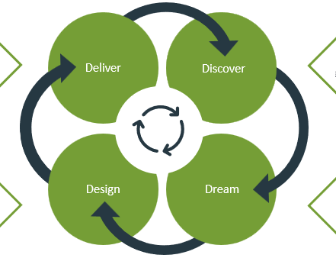

Six of our churches are on the journey with City to City Australia (CTCA) to revitalise their church. The process is outlined below. Presbytery has agreed to a second group of what will be 12 churches to join this journey with CTCA, which will includes 3-4 rural churches and 3-4 Pacific churches. We are now seeking expressions of interest from churches who would like to be part of this second group. Please give either Rod Watts or Emma Keown a call if you want more information or wish to discuss. **Below is a template to complete and send to Natalie** ([administrator@northpres.org.nz](mailto:administrator@northpres.org.nz)) **by 12 July.**

**CTCA’s process of Revitalisation:**

Each of the participating churches will be appointed a CTCA Lead Consultant who will lead the revitalisation process. The CTCA process has 3 phases that build upon each other, these being:

**Phase 1: Research (2-3 months)**

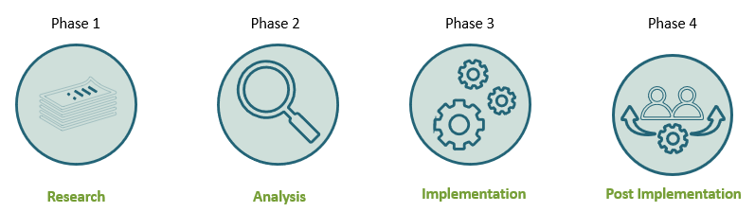Involves the completion of this information which includes:

1. Church Overview: which requests information from the church.
2. Ministry Lead survey: which requests information from the Minister.
3. 360 Review survey: which the Minister completes.
4. Christian life and health survey: which the congregation completes.

This step also includes engagement with the appointed Lead Consultant, particularly with the church’s leadership. Face to face interviews, meetings, attending services, observing the whole life of the church.

**Phase 2: Analysis (1 month)**

The Lead Consultant will arrange to meet with the Church’s leadership and present the findings from the information collected. This is discussed, resulting in the development of a report, which will include recommendations to consider going forward. Following on from this the whole congregation is engaged in a Re Vision Workshop to develop a Pathway or Roadmap, designed to lead the congregation through to implementation.

**Phase 3: Implementation (12 months)**

This stage consists of the implementation of the Development Plan, assisted by the Lead Consultant, who can also draw upon other resources of CTCA to assist, such as:

* Supported specialist expertise to deliver the implementation plan.
* Delivery of coaching, training, and workshops appropriate to recommendations, including areas such as mission & evangelism, financial health, vision, church culture, ministry design, leadership pipelines & development, church planting and proactive conflict leadership
* Participation in CTCA Incubator Core training program for 2 leaders/ church.

**Timeline:**

1. Submit an Expression of Interest by 12th July (see template below)
2. Participating churches confirmed by end of July 2024
3. Participating churches sent introductory information commencing Phase One of the Revitalisation Process by August/September 2024

**Cost:**

The cost of this project is heavily subsidized by NP. The cost to each church is $3000.

This is an investment in the future. An investment in terms of leadership development, church health and growth, renewal in terms of vision and mission, and lives transformed. Whatever your context, we warmly invite you to be part of this exciting step of faith.



**Expression of Interest**

If your church wants to participate in this second group to undergo the CTCA’s revitalisation process then please complete the form below.

* Email to Natalie Stubbs, at ([administrator@northpres.org.nz](mailto:administrator@northpres.org.nz)) by 12th July 2024.
* Churches will be informed whether they are part of Stage 2 by 31st July 2024 (beginning in Aug/Sept 2024)
* For any queries, please contact Rod Watts at ([clerk@northpres.org.nz](mailto:clerk@northpres.org.nz), or 0275208601).
* **Note**; no churches in this second group are required to sign CTCA’s Theological and Ethics Statement

**Name of Church:** ……………………………………………………………..……………………………………………………………

**Contact person:** ….…………………………………………………………………………………………..…………………………….

**Phone:** ……………………………………………………. **Email:** ………………………………………………………………….…….

**Why does your church want to participate in the CTCA revitalisation process?**

………………………………………………………………………………………………………………………………………………….……………….

……………………………………………………………………………………………………………………………………….………………………….

**Are there any concerns or issues your church has at present? If there are, please outline.**

………………………………………………………………………………………………………………………………………………………….…………

…………………………………………………………………………………………………………………………………………………………………….

**Is there a particular development underway, or in planning phase**, that might be incorporated in a church revitalisation process? Please outline if there is.

………………………………………………………………………………………………………………………………………………………….…………

…………………………………………………………………………………………………………………………………………………………………….

…………………………………………………………………………………………………………………………………………………………………….

**What outcomes would your church be seeking with a CTCA revitalisation process**?

………………………………………………………………………………………………………………………………………………………….…………

…………………………………………………………………………………………………………………………………………………………………….

**Signed:** …………………………………………………….. **Name:** …………………………..…………………………

**Email to Natalie Stubbs, at (**[**administrator@northpres.org.nz**](mailto:administrator@northpres.org.nz)**) by Friday 12th July 2024.**